Functional Specification: Open Channel Hydraulics Library

1. Core Architecture & Data Structures
The library must treat channel geometry as an object. The solver functions should take a Channel object and flow parameters as inputs.

1.1 Geometric Cross-Sections
The agent must implement classes for different shapes. Each shape requires a method to calculate Geometric Elements based on a given water depth ($y$).
Key Variables:
- $y$: Flow depth
- $b$: Bottom width
- $z$: Side slope ($z$ horizontal : 1 vertical)
- $D$: Diameter (for circular)
Required Methods per Shape:
- Flow Area ($A$): Cross-sectional area of the water.
- Wetted Perimeter ($P$): Length of the line of intersection of the channel wetted surface with the cross-sectional plane.
- Hydraulic Radius ($R$): $R = A / P$
- Top Width ($T$): Width of the channel section at the free surface.
- Hydraulic Depth ($D_h$): $D_h = A / T$
Formulas to Implement:
Shape | Area (A) | Wetted Perimeter (P) | Top Width (T)
Rectangular | $b \cdot y$ | $b + 2y$ | $b$
Trapezoidal | $(b + zy)y$ | $b + 2y\sqrt{1+z^2}$ | $b + 2zy$
Triangular | $zy^2$ | $2y\sqrt{1+z^2}$ | $2zy$
Circular | $\frac{D^2}{8}(\theta - \sin\theta)$ * | $\frac{1}{2}\theta D$ | $D \sin(\theta/2)$
*Note: For circular sections, $\theta = 2\arccos(1 - \frac{2y}{D})$.

2. Fundamental Flow Modules
These are the physics problems the library must solve.

2.1 Module: Uniform Flow (Manning's Equation)
This assumes slope of energy line ($S_f$) = slope of channel bottom ($S_0$).
The Equation:

$$Q = \frac{k}{n} A R^{2/3} S_0^{1/2}$$
- $Q$: Discharge ($m^3/s$ or $ft^3/s$)
- $n$: Manning's roughness coefficient
- $k$: Unit conversion factor (1.0 for SI, 1.486 for Imperial)
Problems to Solve:
- Solve for Q: Given $y, n, S_0$, and Geometry. (Direct calculation).
- Solve for Normal Depth ($y_n$): Given $Q, n, S_0$, and Geometry.
  - Constraint: This equation is implicit for $y$.
  - Algorithm: Use a numerical root-finding method (e.g., Newton-Raphson or Bisection) to find $y$ such that $Q_{calc}(y) - Q_{target} = 0$.

2.2 Module: Critical Flow & Froude Number
Determine the state of flow (Subcritical, Critical, or Supercritical).
The Equation (Froude Number):

$$Fr = \frac{V}{\sqrt{g D_h}}$$
- If $Fr < 1$: Subcritical (Tranquil)
- If $Fr = 1$: Critical
- If $Fr > 1$: Supercritical (Rapid)
Problems to Solve:
- Calculate State: Return the flow regime for a current state.
- Solve for Critical Depth ($y_c$): The depth at which energy is minimum for a given $Q$.
  - Condition: $Fr = 1$ or $\frac{Q^2 T}{g A^3} = 1$.
  - Algorithm: Numerical root solver required.
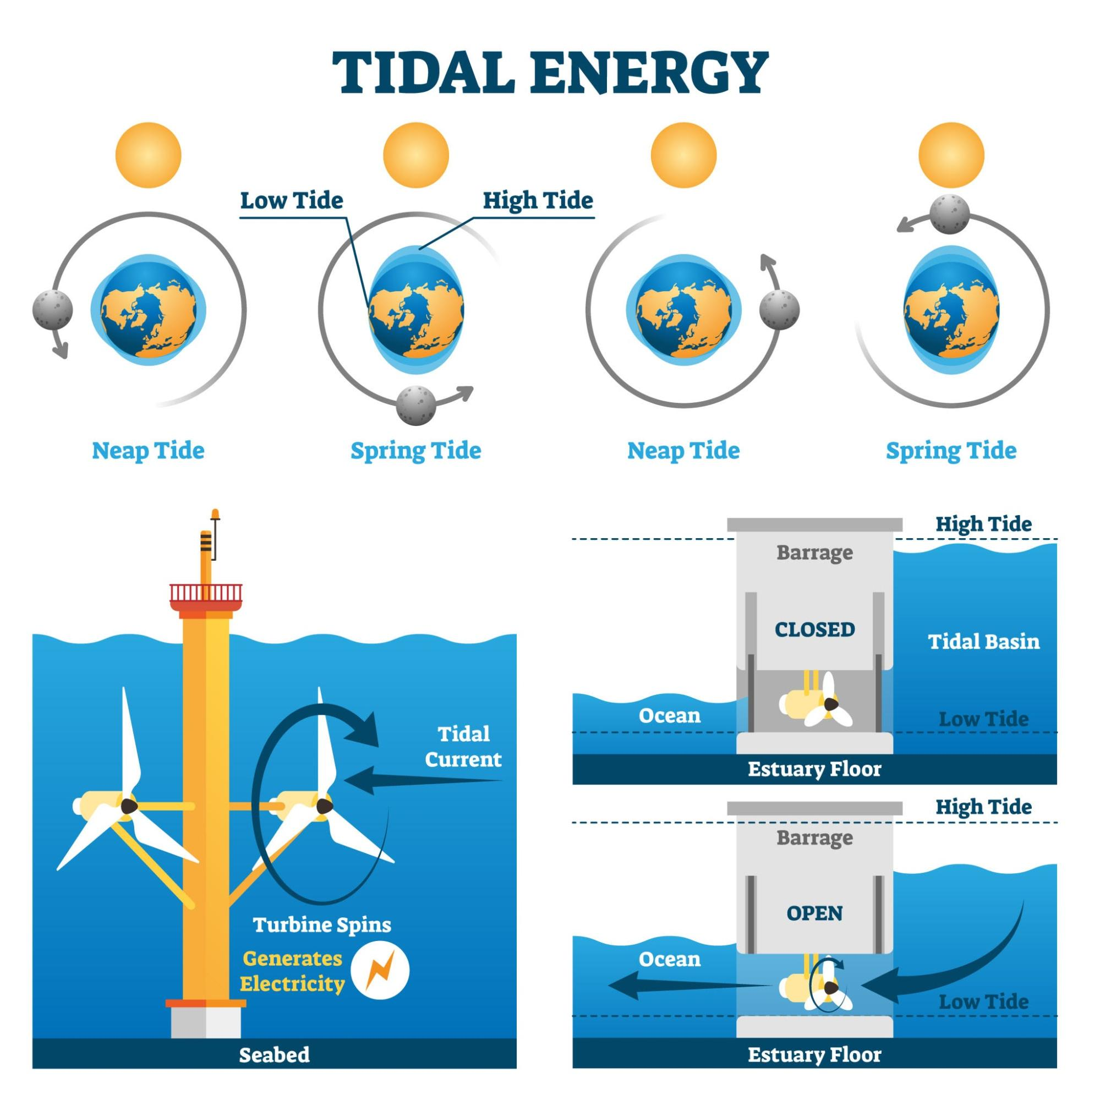Getty Images
Explore

2.3 Module: Specific Energy ($E$)
Used to solve transitions (steps, width constrictions).

$$E = y + \frac{V^2}{2g} = y + \frac{Q^2}{2gA^2}$$
Problems to Solve:
- Alternate Depths: Given a Specific Energy $E$ and a discharge $Q$, find the two possible depths (subcritical and supercritical).

3. Advanced Modules: Flow Profiling
This is the most complex part of the library, handling Gradually Varied Flow (GVF).

3.1 Module: Water Surface Profiles
Calculation of the water surface curve (dy/dx) when flow is not uniform (e.g., behind a dam or approaching a drop).
The GVF Equation:

$$\frac{dy}{dx} = \frac{S_0 - S_f}{1 - Fr^2}$$

Where $S_f$ (Friction Slope) is calculated by rearranging Manning's equation: $S_f = \frac{n^2 V^2}{R^{4/3}}$ (SI units).
Problems to Solve:
- Standard Step Method: Used for natural/irregular channels. Calculate depth at station 2 given depth at station 1.
- Direct Step Method: Used for prismatic (artificial) channels. Calculate the distance $\Delta x$ between two known depths.

4. Hydraulic Structures Module
Equations for specific control structures.

4.1 Hydraulic Jumps
Occurs when flow transitions from Supercritical to Subcritical.

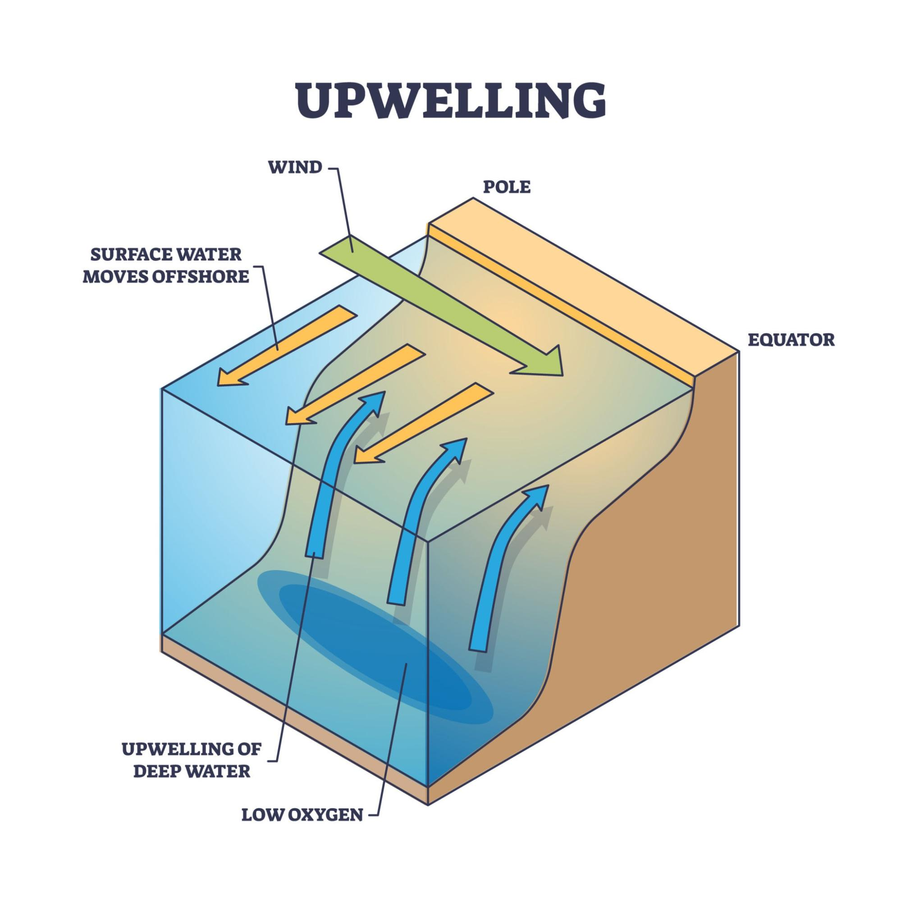
Getty Images

Problems to Solve:
- Conjugate Depth ($y_2$): Given an upstream supercritical depth $y_1$, find the downstream subcritical depth.
  - General Formula (Rectangular): $\frac{y_2}{y_1} = \frac{1}{2}(\sqrt{1 + 8Fr_1^2} - 1)$
- Energy Loss: Calculate head loss ($\Delta E$) across the jump.

4.2 Weirs and Gates
- Rectangular Weir: $Q = C_d L H^{3/2}$
- V-Notch Weir: $Q = C_d \tan(\frac{\theta}{2}) H^{5/2}$
- Sluice Gate: Flow under a gate.

5. Technical Implementation Guidelines for the AI
When prompting the AI, include these technical constraints:
- Units: The library must handle both SI (metric) and English units via a configuration flag or class attribute.
- Numerical Methods: Do not rely on "trial and error." Use scipy.optimize.newton or scipy.optimize.brentq for solving implicit equations (Normal Depth $y_n$ and Critical Depth $y_c$).
- Error Handling: Raise specific errors for physically impossible inputs (e.g., negative depth, or finding normal depth for a horizontal slope where $S_0=0$).
- Dependencies: Prefer numpy for array handling and scipy for optimization.

